1.5kw Lo-Hi Larcan 6 meter conversion
By Ed Finn WA3DRC
After converting one Larcan Lo-Hi unit to 144 mHz using the conversion notes from Corey Abercrombie, I acquired a second Lo-Hi with intentions of using it on six meters.
There are a few web sites with conversion information but I did not find information on converting the larger 1500 Watt 6-device units for 6 meters. The input splitter and output combiner circuits were a bit different so I had to develop a method to make this work. It would also become a nice project to use a new NanoVNA I had purchased on Ebay.
The hard work on this conversion had already been done and published by Dave Olean, K1WHS in his article dated 2/9/2012. He converted a 1KW 4-device unit. The 4 and 6-device units share the same building block stages which include the same pcb layout, so I used Dave’s notes. Dave also isolated all the stages from the splitter/combiner and used 50 ohm surface mount resistors to terminate in place of the active stages. This seemed like a great place to start with the splitter/combiners.
Backing up for a minute… The Larcan documentation starts out with values for a Lo-Lo unit and has values to convert to higher frequencies. The first step to convert this unit was to basically convert it back to a Lo-Lo and then reconcile the updates in the active device stages with Dave’s recommendations. Then I looked at the return loss into the output and again at the input and made adjustments for a good match with the resistors temporarily installed.
Once the active amplifier stages were isolated by unsoldering the center conductor of the coax and putting in 50 ohm resistors in their place I looked into the output with the VNA. The return loss (RL) was already very good (~30dB) at 50 MHz. I did not make any changes on this side, aside from reverting the changes from Lo-Hi to Lo-Lo. See figure 1 for the sweep. So you could skip the termination step on the output side for conversion.
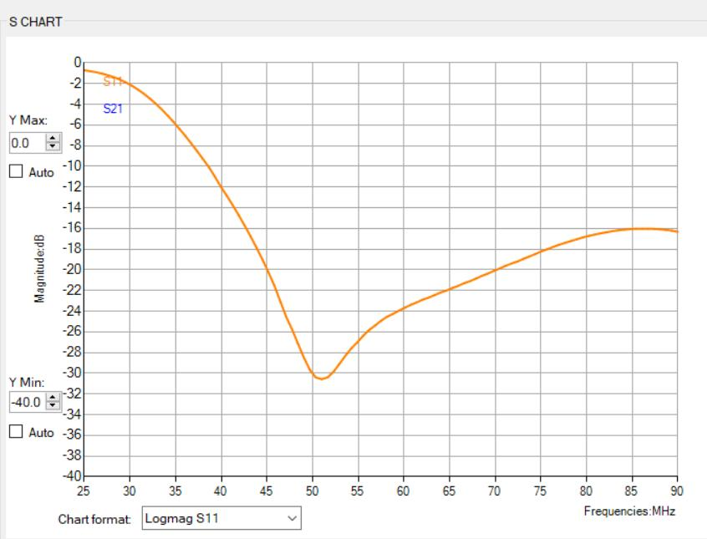
Figure 1. Output Combiner Sweep
The input match at 50 MHz was not horrible either. The best RL there was at 68MHz (26.5db). At 50 MHz it was 16.8db, still not horrible. Poking a finger around the input provided some clues. The first cap near the BNC seemed to want more capacitance. After a few substitutions I found that 12pf at C148 improved the RL to 27.2 db. I see in my notes that stacking another 4.7 pf on top of the 33pf C145 was done at the same time. It seemed like it was time to stop. Figure 2 shows the sweep after changing C148. The C145 change made it a little better, but I did not capture the sweep.
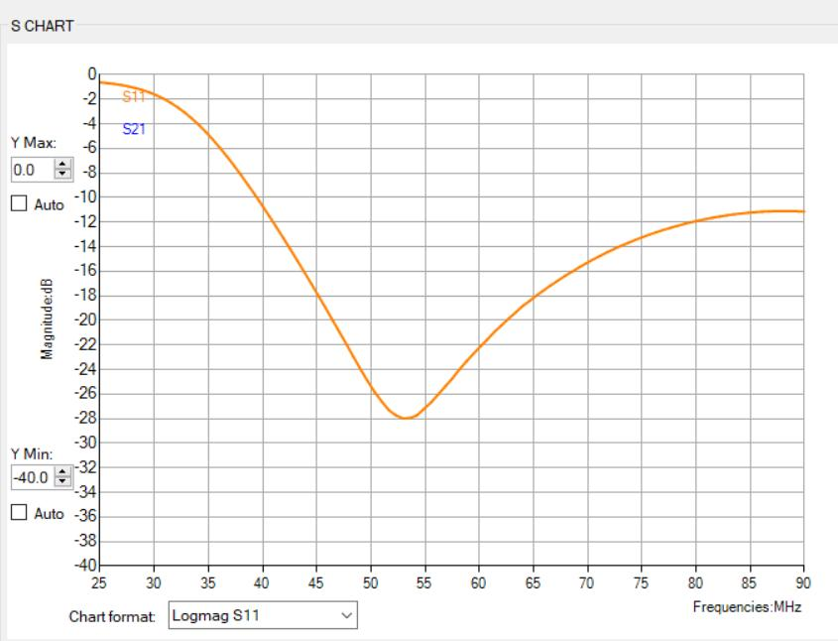
Figure 2. Input sweep in terminating resistors.
At this time I removed the temporary resistors on the input side and reconnected to the splitter circuit. I tested each of the 6 stages independently before removing the temporary 50 ohm resistors on the outputs (after setting their bias’ to 500mA per half stage). When testing a stage, remove fuses from the other stages. Each stage should contribute about 250 watts if all is well using a temporary coax connection on the output. Figure 3 shows a sweep of the input after reconnection to the active stages, but unpowered. (K1WHS saw this behavior too.)
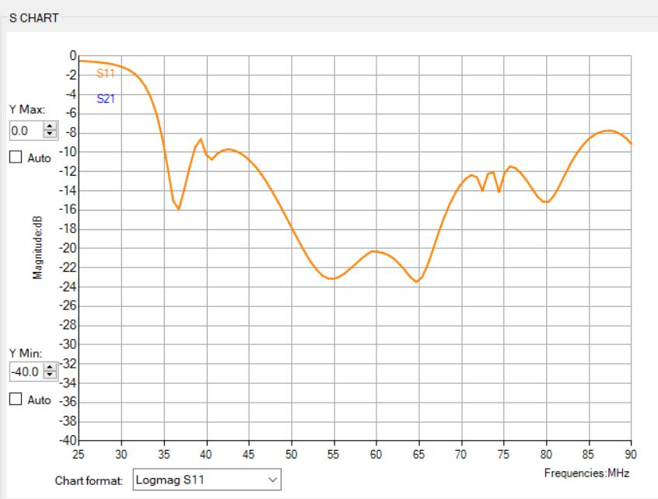
Figure 3. Input into unpowered amplifier modules
One NOTE (learned the hard way); “death to these $100 devices is overdrive”. The efficiency after this mod was better than the 2 meter mod and this got me in trouble. The 2 meter Larcan produced 1500 watts with 15 watts in, so this was the limit I was trying to stay below. It turns out that this was not a good assumption and I lost 2 devices.
After figuring this out and replacing devices the reduced power applied was making each device produce at least 250 watts. At this point the temporary output resistors were removed and the output combiners reattached. Time for final test…
Connected to a load and with in/out wattmeters in place, the amplifier now was making 1500w with 6 watts input power. The devices are more efficient at 50 MHz and the input splitter is probably more efficient. My limit of 15 watts based on the 2 meter conversion was pushing the devices to 2x the desired output. Don’t overdrive!
I did one more thing to both the 2 meter and 6 meter Larcan. The protection board is not great for amateur service. I removed some hot plug circuitry as it is not needed. I also did a characterization of the coupler circuits on the output of amp to try to dial in the existing circuit to do some swr protection. It is a symmetrical layout with identical components for forward and reverse detection.
I noted the forward voltage at various output power levels and populated the data into excel. I did this for bot the 2 and 6 meter conversions and found the voltage I was comfortable with for reflected power. I am hesitant to publish a voltage “setting” as I don’t want to have you blame me for smoking $100 devices, but I picked a value and set the wiper of R21 to that value.
My conversion removes the gate voltage in standby or over-SWR. An issue I see with these is that in operation, if you remove the (positive) gate voltage the output does not go to zero. The devices are still not cutoff, so the protection is not guaranteed. It is probably a good idea to put some negative voltage on the gate to turn it off completely.
As I did the detector analysis and some spice simulation on the Larcan protection circuit, this is a topic for another article.
I hope this helps! I have the amp in place to try in the January 2020 vhf contest. I’ll see if it survives! Also, this was a nice first use for the nanoVNA. The human interface is bad but the instrument is fine.
Here is a shot of the amp (Figure 3.) ready to try in the January contest. One last task; connect the antenna…
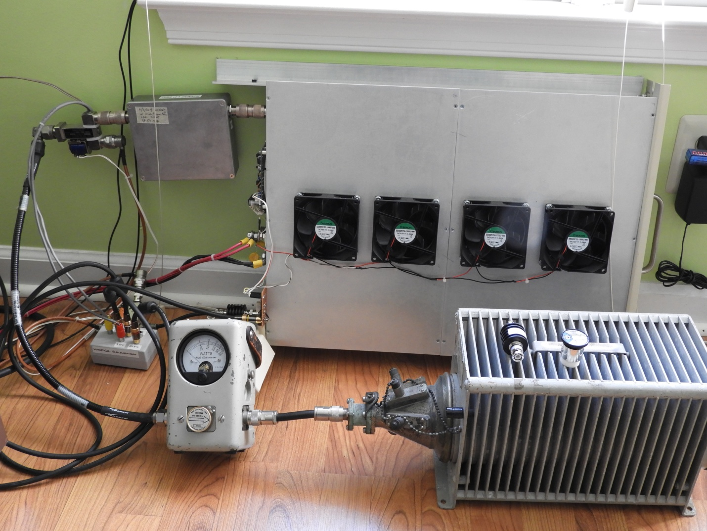
Figure 3. Final Test with amplifier, sequencer, relays, LP filter, dummy load

